Polyline
# Source: AI Source: Provided by: [Data Path: Persons Table -> ID Column: 1, Name_En Column: Motasem Essam] -> From: [ChatGPT] on [7/25/2026]
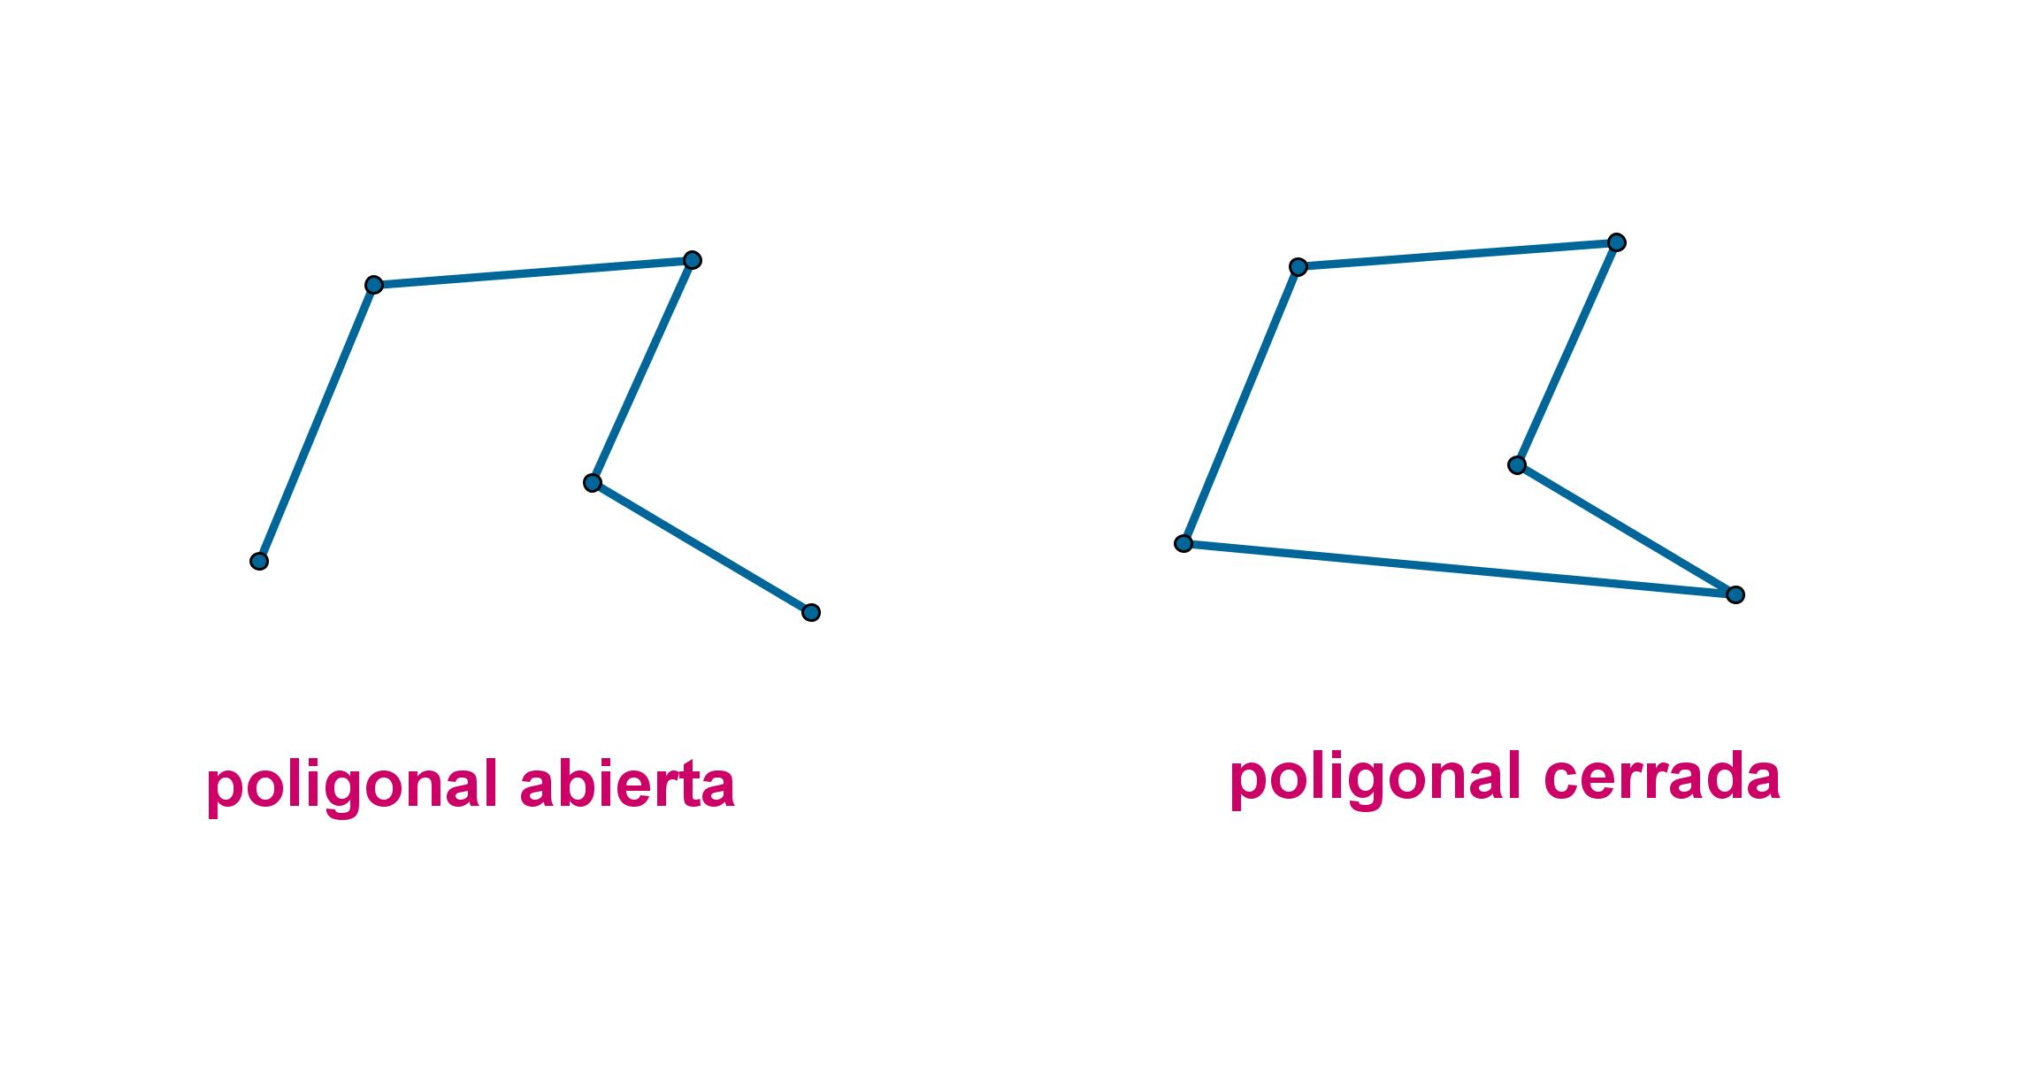
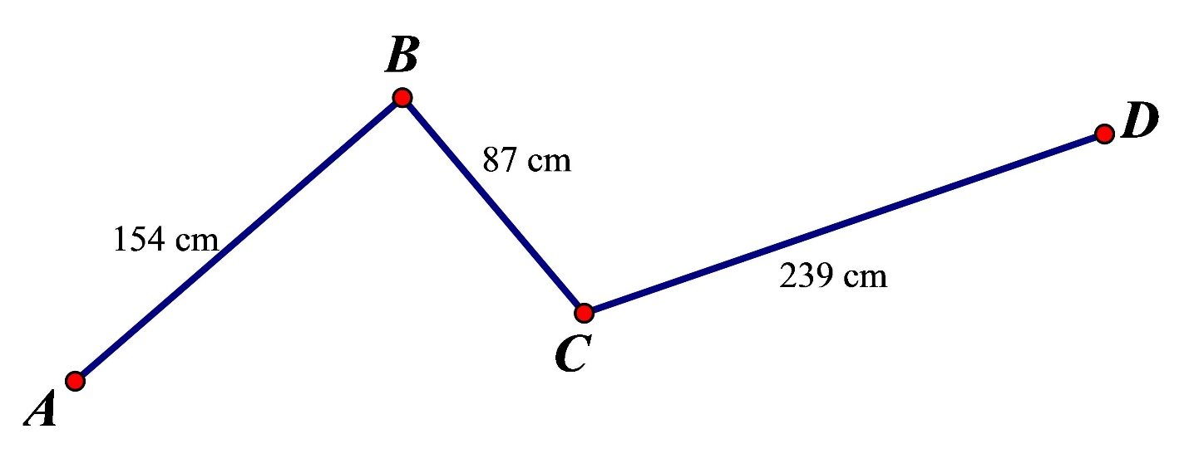
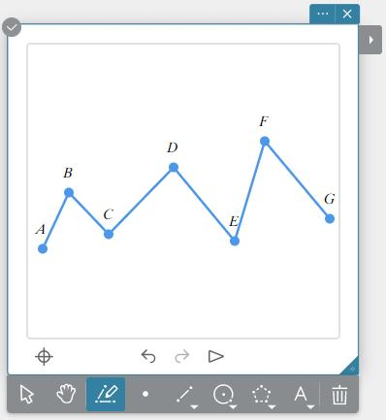
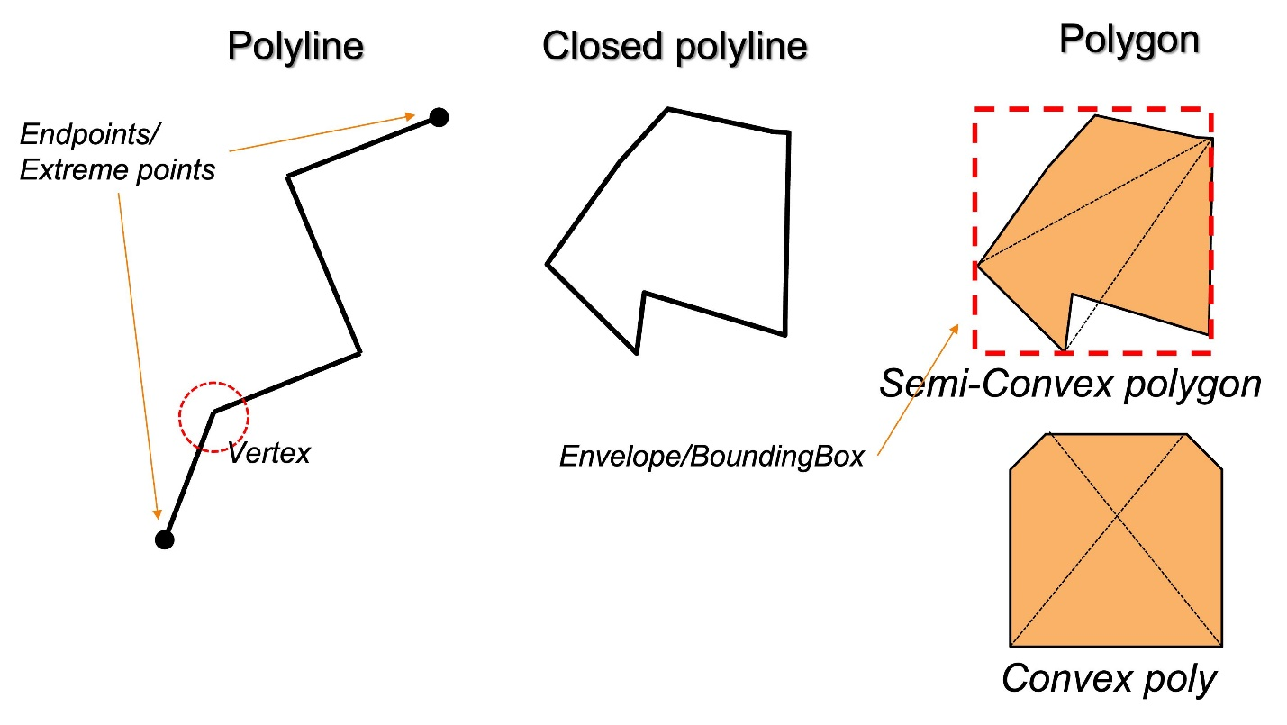
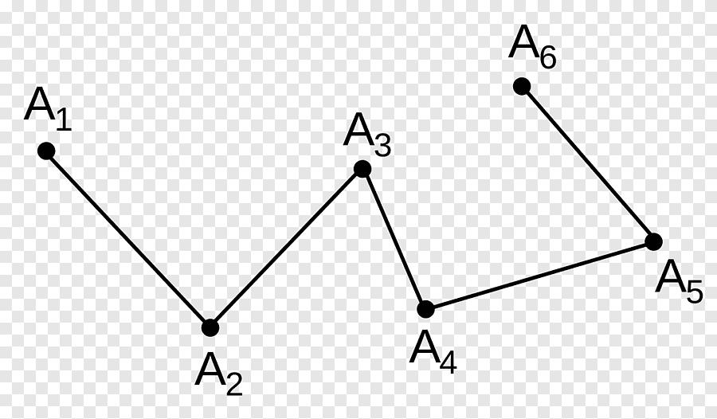
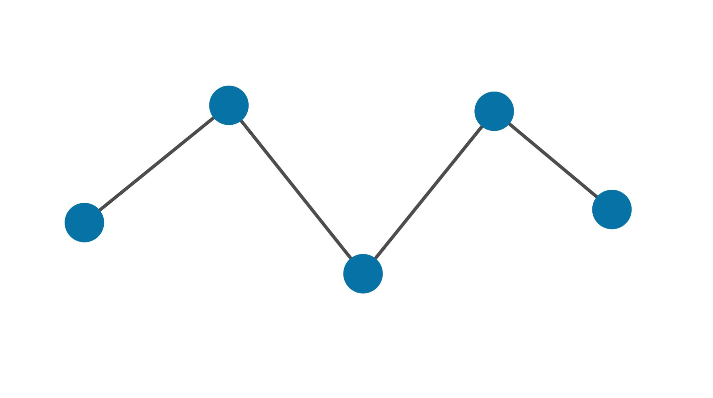

Definition
# Source: AI Source: Provided by: [Data Path: Persons Table -> ID Column: 1, Name_En Column: Motasem Essam] -> From: [ChatGPT] on [7/25/2026]
A Polyline is a continuous geometric figure formed by connecting two or more straight line segments end to end. Each segment shares an endpoint with the next segment, creating a chain-like path.
A polyline does not have to be closed. If its first and last points are different, it is an open polyline. If its first and last points coincide, it forms a closed polyline, which is the boundary of a polygon.

Characteristics
# Source: AI Source: Provided by: [Data Path: Persons Table -> ID Column: 1, Name_En Column: Motasem Essam] -> From: [ChatGPT] on [7/25/2026]
A polyline:
- Is made entirely of straight line segments.
- Has one or more vertices where segments meet.
- May be open or closed.
- May change direction at each vertex.
- Has measurable total length.
- Does not contain curved sections.

Illustration

Open Polyline
# Source: AI Source: Provided by: [Data Path: Persons Table -> ID Column: 1, Name_En Column: Motasem Essam] -> From: [ChatGPT] on [7/25/2026]
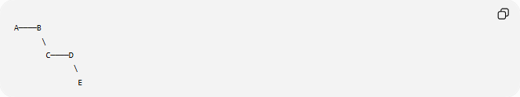
A────B
\
C────D
\
E
The connected segments form an open polyline.

Closed Polyline
# Source: AI Source: Provided by: [Data Path: Persons Table -> ID Column: 1, Name_En Column: Motasem Essam] -> From: [ChatGPT] on [7/25/2026]
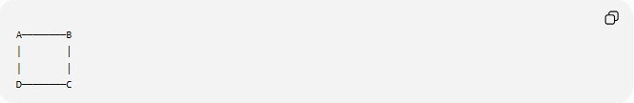
A────────B
│ │
│ │
D────────C
This is a closed polyline because it returns to its starting point.

Components of a Polyline
# Source: AI Source: Provided by: [Data Path: Persons Table -> ID Column: 1, Name_En Column: Motasem Essam] -> From: [ChatGPT] on [7/25/2026]
A polyline consists of:
- Vertices (points where segments meet).
- Line segments connecting consecutive vertices.
Example:
Vertices:
$$A,B,C,D$$
Segments:
$$\overline{AB},\overline{BC},\overline{CD}$$

Mathematical Representation
# Source: AI Source: Provided by: [Data Path: Persons Table -> ID Column: 1, Name_En Column: Motasem Essam] -> From: [ChatGPT] on [7/25/2026]
A polyline can be represented by an ordered list of vertices:
$$P_{1},P_{2},P_{3},…,P_{n}$$
Each consecutive pair defines one segment:
$$\overline{P_{1}P_{2}},\overline{P_{2}P_{3}},…,\overline{P_{n-1}P_{n}}$$

Length of a Polyline
# Source: AI Source: Provided by: [Data Path: Persons Table -> ID Column: 1, Name_En Column: Motasem Essam] -> From: [ChatGPT] on [7/25/2026]
The total length of a polyline equals the sum of the lengths of all its segments.
If the segment lengths are:
$$L_{1},L_{2},…,L_{n}$$
then:
$$L=L_{1}+L_{2}+⋯+L_{n}$$

Types of Polylines

1. Open Polyline
# Source: AI Source: Provided by: [Data Path: Persons Table -> ID Column: 1, Name_En Column: Motasem Essam] -> From: [ChatGPT] on [7/25/2026]
The first and last vertices are different.
Example:
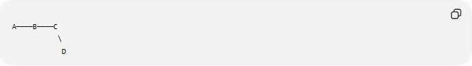
A────B────C
\
D

2. Closed Polyline
# Source: AI Source: Provided by: [Data Path: Persons Table -> ID Column: 1, Name_En Column: Motasem Essam] -> From: [ChatGPT] on [7/25/2026]
The first and last vertices coincide.
Example:
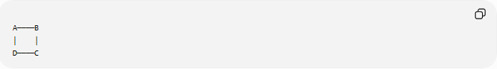
A────B
│ │
D────C
Every polygon is formed by a closed polyline.

Examples
# Source: AI Source: Provided by: [Data Path: Persons Table -> ID Column: 1, Name_En Column: Motasem Essam] -> From: [ChatGPT] on [7/25/2026]
Example 1
Vertices:
$$A,B,C$$
Segments:
$$\overline{AB}$$
$$\overline{BC}$$
This forms an open polyline.

Example 2
Four connected segments returning to the starting point form a closed polyline (a quadrilateral boundary).

Real-World Examples
# Source: AI Source: Provided by: [Data Path: Persons Table -> ID Column: 1, Name_En Column: Motasem Essam] -> From: [ChatGPT] on [7/25/2026]
Polylines appear in:
- Roads on maps.
- Hiking trails.
- Railway routes.
- Electrical wiring diagrams.
- River centerlines (approximated).
- Computer graphics.
- CAD drawings.
- GPS navigation paths.
- Building outlines.
- Survey boundaries.

Applications
# Source: AI Source: Provided by: [Data Path: Persons Table -> ID Column: 1, Name_En Column: Motasem Essam] -> From: [ChatGPT] on [7/25/2026]
Polylines are widely used in:
- Plane Geometry
- Coordinate Geometry
- GIS (Geographic Information Systems)
- CAD (Computer-Aided Design)
- Computer Graphics
- Engineering
- Surveying
- Robotics
- Navigation Systems
- Cartography

Advantages
# Source: AI Source: Provided by: [Data Path: Persons Table -> ID Column: 1, Name_En Column: Motasem Essam] -> From: [ChatGPT] on [7/25/2026]
Studying polylines helps to:
- Represent complex paths.
- Approximate curved shapes with straight segments.
- Calculate path lengths.
- Model roads, routes, and boundaries.
- Build polygonal figures.

Limitations
# Source: AI Source: Provided by: [Data Path: Persons Table -> ID Column: 1, Name_En Column: Motasem Essam] -> From: [ChatGPT] on [7/25/2026]
A polyline:
- Contains only straight segments.
- Does not represent smooth curves directly.
- May require many segments to approximate a curved path accurately.

Comparison with Related Concepts
# Source: AI Source: Provided by: [Data Path: Persons Table -> ID Column: 1, Name_En Column: Motasem Essam] -> From: [ChatGPT] on [7/25/2026]
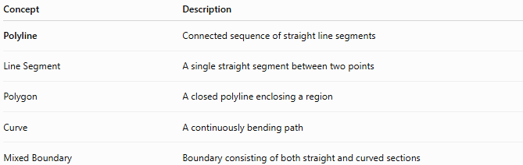
Concept | Description
Polyline | Connected sequence of straight line segments
Line Segment | A single straight segment between two points
Polygon | A closed polyline enclosing a region
Curve | A continuously bending path
Mixed Boundary | Boundary consisting of both straight and curved sections

Key Points
# Source: AI Source: Provided by: [Data Path: Persons Table -> ID Column: 1, Name_En Column: Motasem Essam] -> From: [ChatGPT] on [7/25/2026]
- A Polyline is a connected chain of straight line segments.
- It may be:
  - Open
  - Closed
- Its total length is the sum of its segment lengths.
- A closed polyline forms the boundary of a polygon.
- Polylines are widely used in mapping, engineering, CAD, and computer graphics.

Conclusion
# Source: AI Source: Provided by: [Data Path: Persons Table -> ID Column: 1, Name_En Column: Motasem Essam] -> From: [ChatGPT] on [7/25/2026]
A Polyline is a continuous geometric figure formed by connecting multiple straight line segments end to end. It can be open or closed, and when closed it serves as the boundary of a polygon. Polylines are fundamental in plane geometry, coordinate geometry, engineering, surveying, GIS, CAD, computer graphics, robotics, navigation, and cartography, where they are used to represent paths, outlines, routes, and complex shapes using straight segments.

